**Experiment No:1**

**Aim:**

**CO:**

**Procedure:**

**Output Screenshot:**

**Result:**

**Experiment No:2**

**Aim:**

**CO:**

**Procedure:**

**Output Screenshot:**

**Result:**

**Experiment No:3**

**Aim:** Familiarization of linux commands.

**CO 2:** Perform system administration.

**Procedure:**

**1) pwd :-** To identify the path of the working directory.

**$pwd**

**Output Screenshot:**



**2) ls :-** To list the files and content.

**$ls**

**Output Screenshot:**



**2.1) ls -R :-** Tolist the contents of subdirectories.

**$ls -R**

**Output Screenshot:**

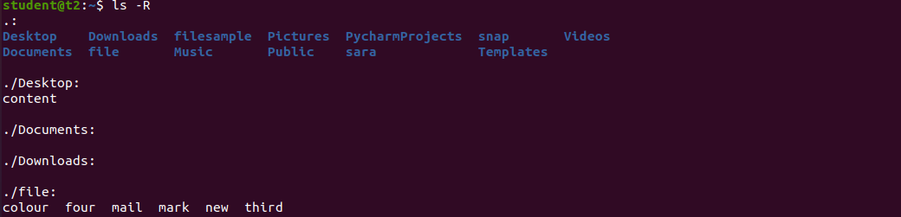

**2.2) ls -l** **:-** Long listing of contents.

**$ls -l**

**Output Screenshot:**

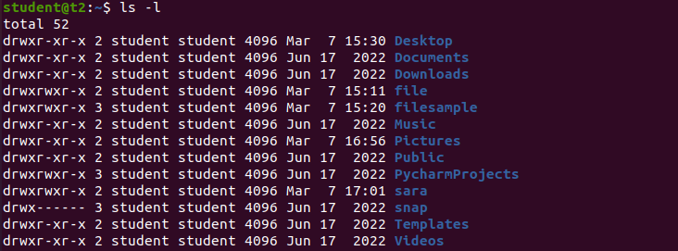

**2.3) ls -a :-** To view hidden files.

**$ls -a**

**Output Screenshot:**

**2.4) ls -al :-** We canlist files and dictionaries with detailed information.

**$ls -al**

**Output Screenshot:**

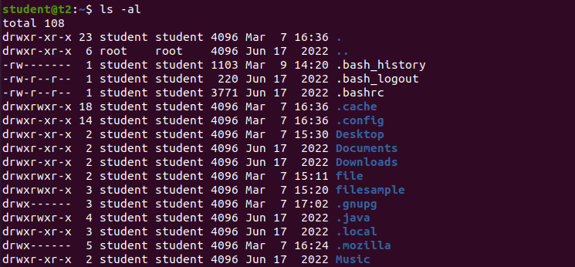

**2.5) ls -t :-** To list the files sorted in the order of last modified.

**$ls -t**

**Output Screenshot:**



**2.6) ls -r :-**

**Output Screenshot:**



**3) mkdir :-** To create a new directory.

**$mkdir athirakp**

**Output Screenshot:**



**4) cd :-** To navigate through the directory.

**$cd athirakp**

**Output Screenshot:**



**5) cd -- :-** To move one step back to from the directory.

**$cd --**

**Output Screenshot:**



**6) history :-** To view the history and the commands which you have been executed for certain period of time.

**$history**

**Output Screenshot:**

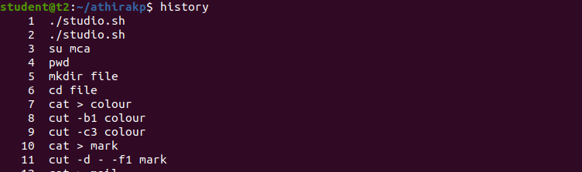

**7) man :-** We can learn and understand about different commands right from shell.

**$man ls**

**Output Screenshot:**



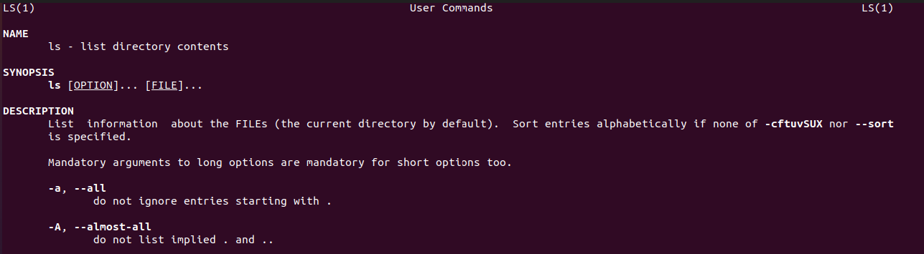

**8) cat > file_name :-** To create a file.

**$cat > MCA**

**Output Screenshot:**

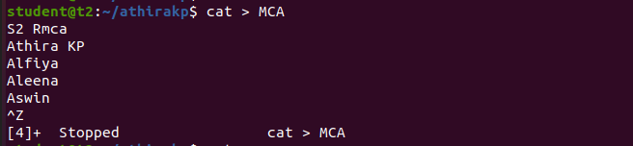

**9) cat file_name:-** To display contents in a file.

**$cat MCA**

**Output Screenshot:**

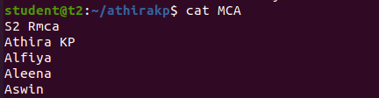

**10) cat > > file_name:-** To append content to the existing file.

**$cat >> MCA**

**Output Screenshot:**

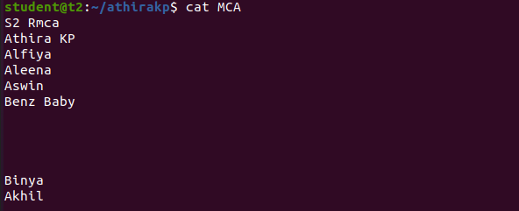

**10.1) cat -n file_name :-** To display line with numbers

**$cat -n MCA**

**Output Screenshot:**

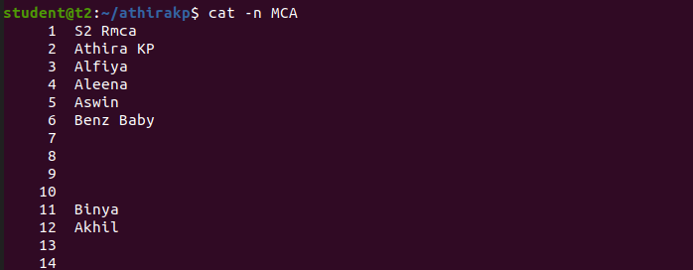

**10.2) cat -b file_name :-** To remove numbering of empty lines

**$cat -b MCA**

**Output Screenshot:**

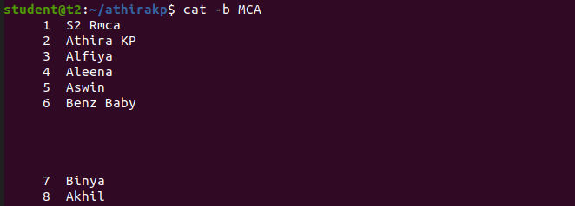

**Result:** The program is executed successfully and the output is verified

**Experiment No:4**

**Aim:**

**CO:**

**Procedure:**

**Output Screenshot:**

**Result:**